PeopleDesk Security Teardown — An Attacker's Morning
Training use only. Same evidence as before, told in the order an attacker would actually encounter it: find the repo, pull the data, see what it costs — then how it gets caught. PeopleDesk and its three "customers" are fictional throughout; no real customer or employee data is involved anywhere in this project.

1. Someone outside the company finds the repo
It's public. Anyone can find it — a search, a link, doesn't matter how. What they find inside is what the rest of this document walks through.

2. The thing that doesn't go away
The repo's first commit hardcoded three fake secrets directly in config.js. GitHub caught it at push time — real terminal output, not staged:
remote: error: GH013: Repository rule violations found for refs/heads/main.
remote: - GITHUB PUSH PROTECTION
remote: Resolve the following violations before pushing again
remote: - Push cannot contain secrets
remote: —— Slack Incoming Webhook URL ——
remote: locations:
remote: - commit: 11086aa4e111fedb4c6258cddda48a21b17f5307
remote: path: config.js:18
! [remote rejected] main -> main (push declined due to repository rule violations)
The secret was later rotated to environment variables — but the point worth sitting with is what rotation does and doesn't fix:

Before
module.exports = {
ADMIN_PASSWORD: "SuperSecret123!",
SLACK_WEBHOOK_URL: "https://hooks.slack.com/services/T05G8QZ2P1K/...",
AWS_ACCESS_KEY_ID: "AKIAZQ3XJK7LPMND2Q8H",
};

After
module.exports = {
ADMIN_PASSWORD: process.env.ADMIN_PASSWORD,
SLACK_WEBHOOK_URL: process.env.SLACK_WEBHOOK_URL,
AWS_ACCESS_KEY_ID: process.env.AWS_ACCESS_KEY_ID,
};
Rotating a leaked secret stops it from being used going forward. It does not erase the fact that it leaked — the original commit is still in git history, permanently.
Most people assume "we fixed it" means "it's gone." It doesn't.

3. One command
No login, no token, no header of any kind. This is the actual live response from the deployed app:
[{"id":1,"name":"Kavindu Perera","email":"kavindu.perera@example.com",
"phone":"+94 71 000 0001","issue":"Cannot reset password",
"notes":"Customer sounded frustrated on the call."},
{"id":2,"name":"Amara Silva", "email":"amara.silva@example.com", ...},
{"id":3,"name":"Nadeesha Fonseka", ... ,
"notes":"GDPR-style access request — flagged for legal review."}]
Fetched live from https://peopledesk-demo.vercel.app/api/tickets (attacker-scrape.js formats this as a table for the live demo). Names/emails/phone numbers are fictional, the exposure mechanism is real.
That's 3 people in under a second. For a real system with 50,000 customers, it's the exact same command.

4. Raise the stakes on the password
This doesn't require anyone to break into a database. The admin password is logged in plaintext on every login attempt:
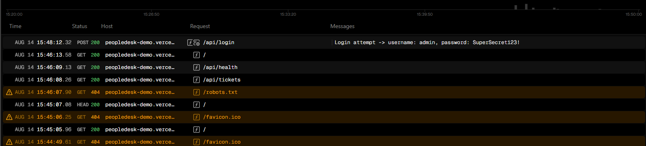
Vercel dashboard → Logs: the POST /api/login request shows "Login attempt -> username: admin, password: SuperSecret123!" in plaintext, no redaction.
Anyone who ever gets read access to logs — a much lower bar than production database access — has the real admin credential.

5. What this actually turns into
A technical finding is abstract. This is what it becomes once it reaches a customer, a regulator, or a headline.

Mock breach notification email
SPECIMEN — FOR INTERNAL TRAINING USE ONLY — NOT A REAL COMMUNICATION
Subject: Notice of a data security incident affecting your account
Dear [Customer], we are writing to inform you of a data security incident that may have affected your personal information. On [date], we discovered that a support-ticket API endpoint did not require authentication, meaning your name, email address, phone number, and support notes were accessible to anyone with the URL, for an undetermined period of time. We have no evidence of malicious use at this time, but are notifying you as a precaution.

Mock headline
"Support platform left customer data open for months — no login required" — fictional trade-press headline, for illustration only.

The number that makes it concrete
GDPR's maximum fine for this class of violation (Article 32, security of processing) is up to 4% of global annual turnover, or €20 million — whichever is higher. Public, general knowledge, not legal advice. NIS2 (Article 21) separately requires certain organizations to report significant incidents within tight timelines — which is exactly what the process failures in section 6 make harder to hit, because nobody was watching until it was too late.

6. How this gets caught
Everything above was findable by a script or a settings page. Here's what actually closes the window — not shown for its own sake, but as the direct answer to what you just read.

Before: merged without review
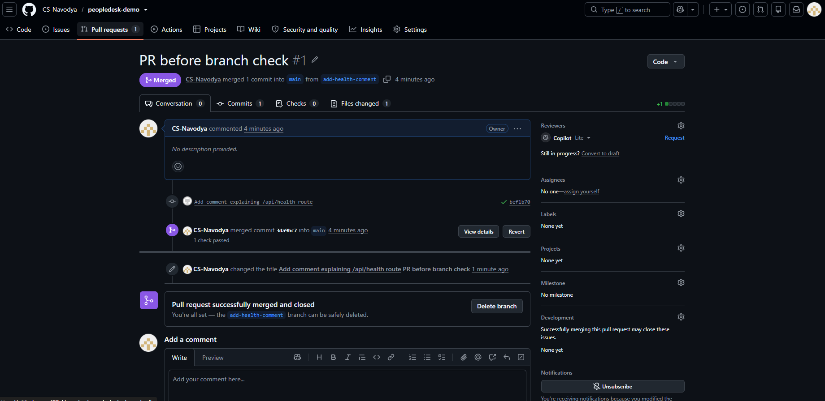
PR #1 ("add-health-comment") merged directly into main — no review requested, no status checks in place. This is how long a hole like the one above can sit open: indefinitely, if nobody is required to look.

Branch protection rule
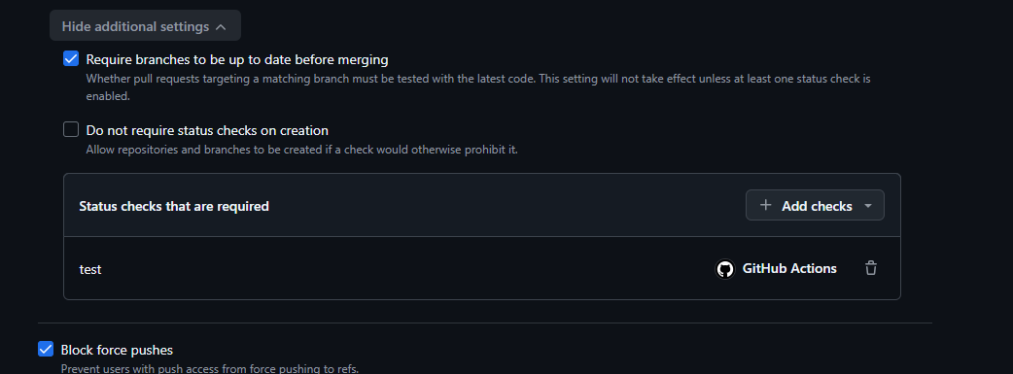
Settings → Branches → main: pull request required before merging, the CI "test" status check required, force pushes blocked.

After: blocked until checks pass
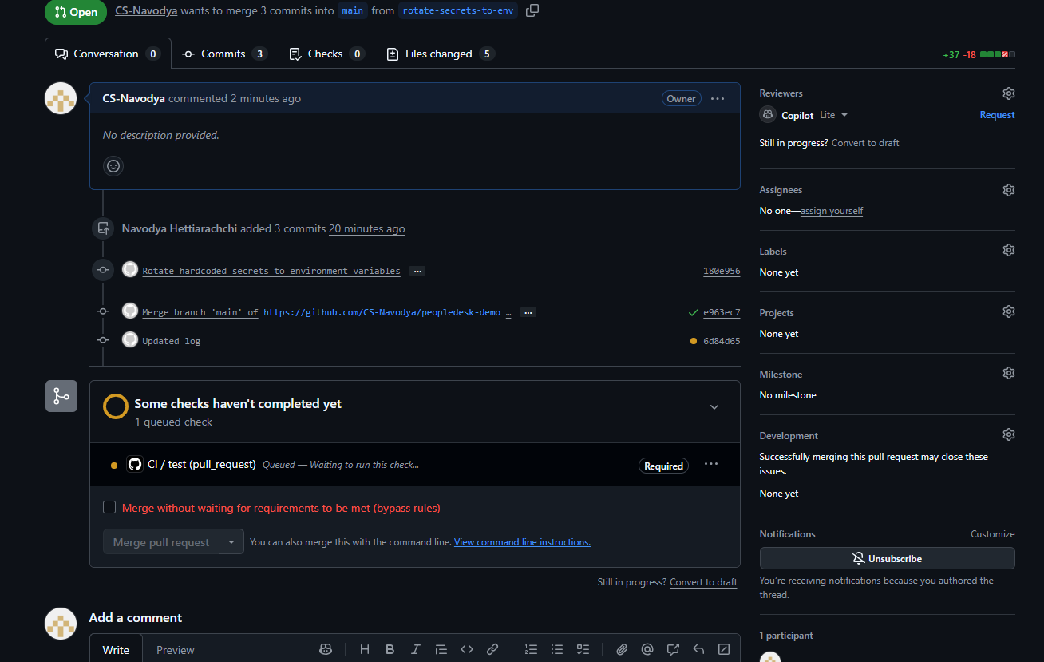
PR #2 ("rotate-secrets-to-env") sitting blocked — "Some checks haven't completed yet," required CI check queued.

After: merged once CI passed
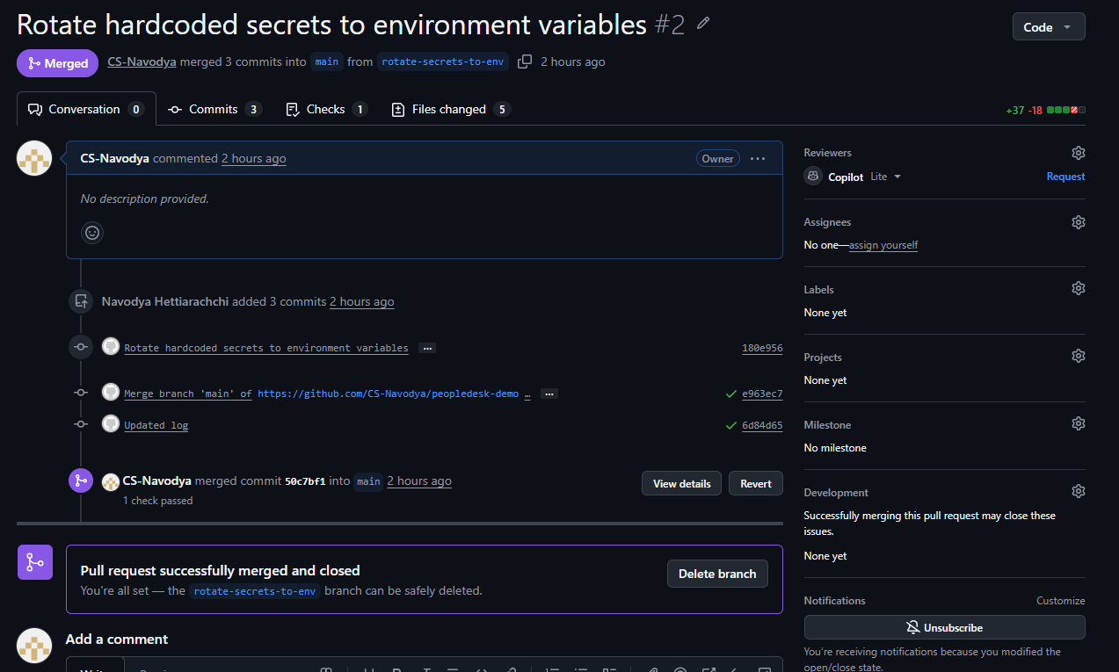
PR #2 ("rotate-secrets-to-env") merged once the required CI check passed — contrast with the blocked state above.

Dependabot: the automated version of the same idea
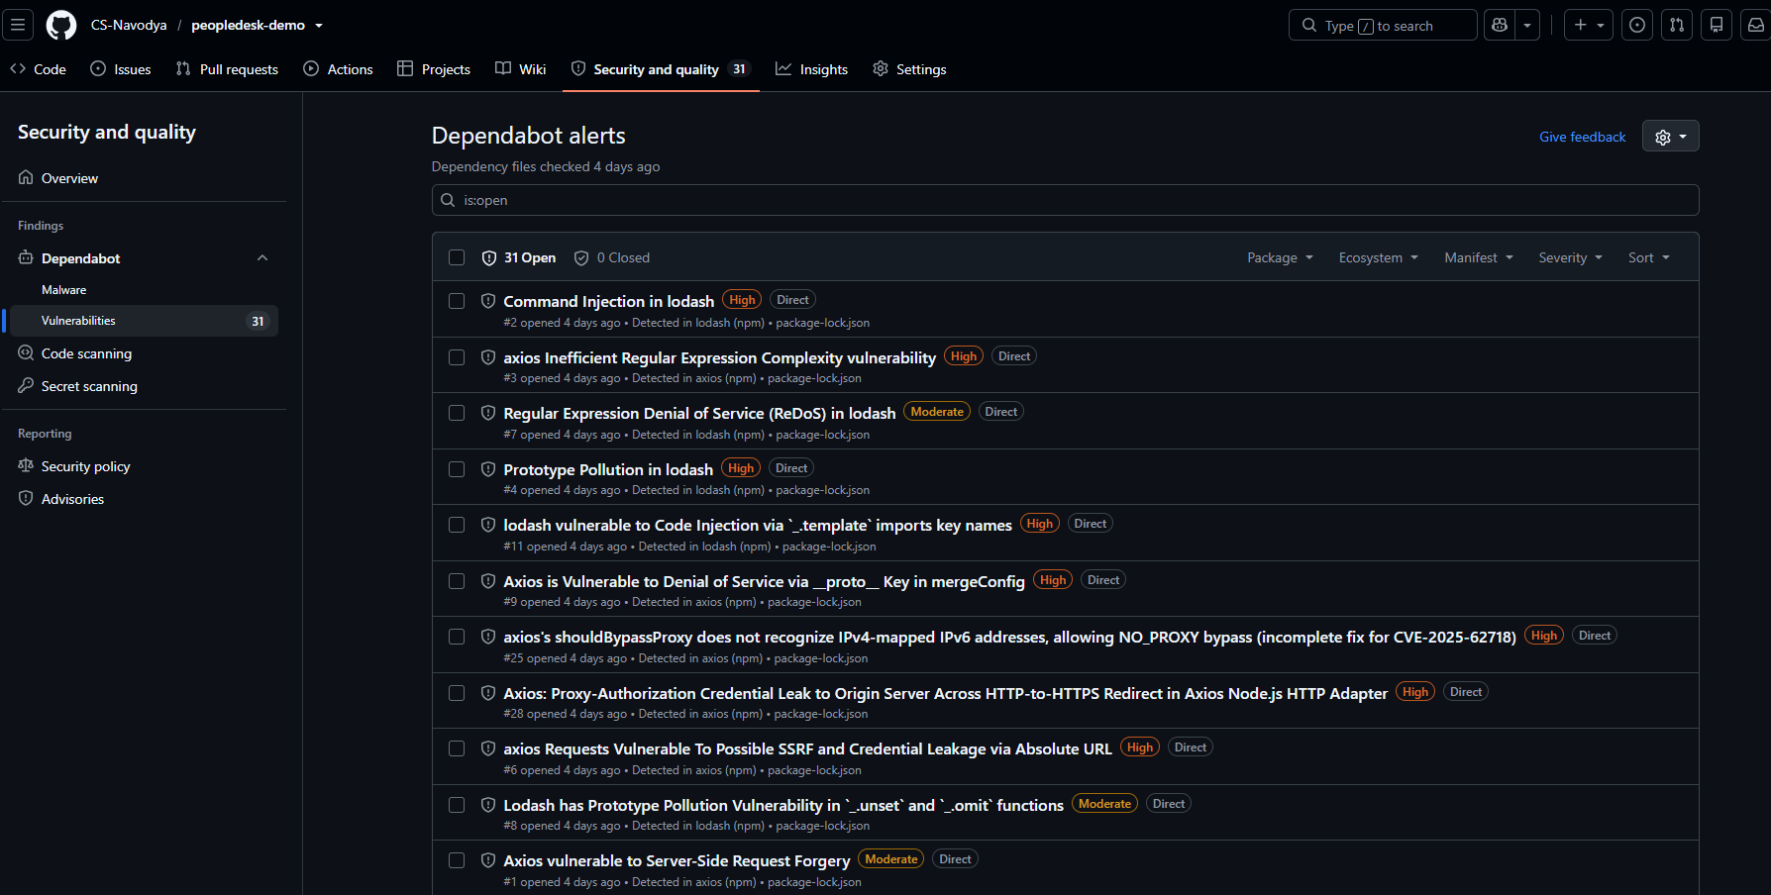
Security → Dependabot → 31 open alerts across lodash and axios, several rated High (prototype pollution, SSRF, credential leak) — independently confirming the same risk npm's own audit flagged locally. Something is watching, even when no one remembers to check.

Security & Quality overview, current state
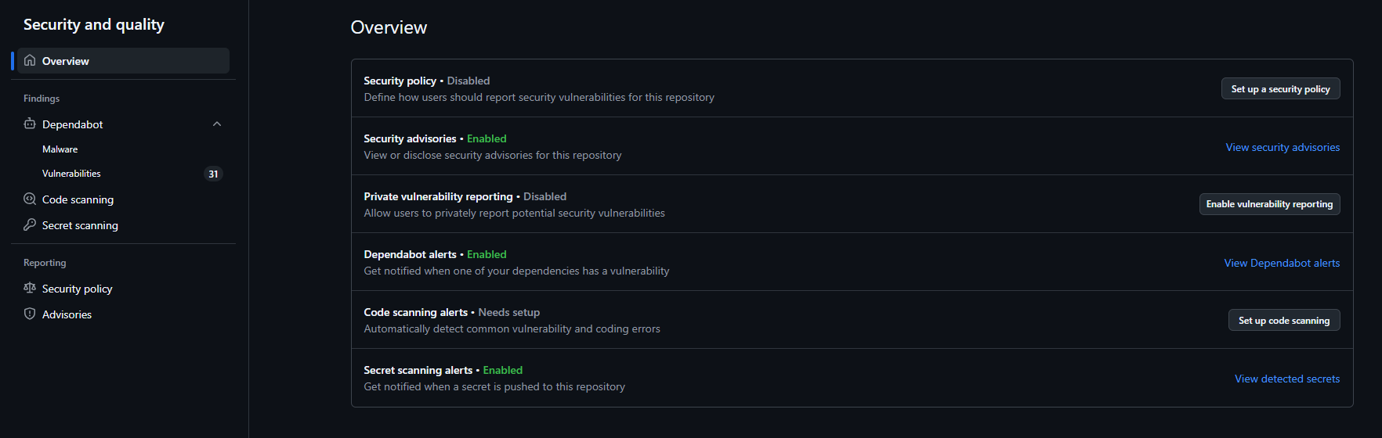
Security and quality → Overview: Dependabot alerts and Secret scanning both now show Enabled.

7. Deployment
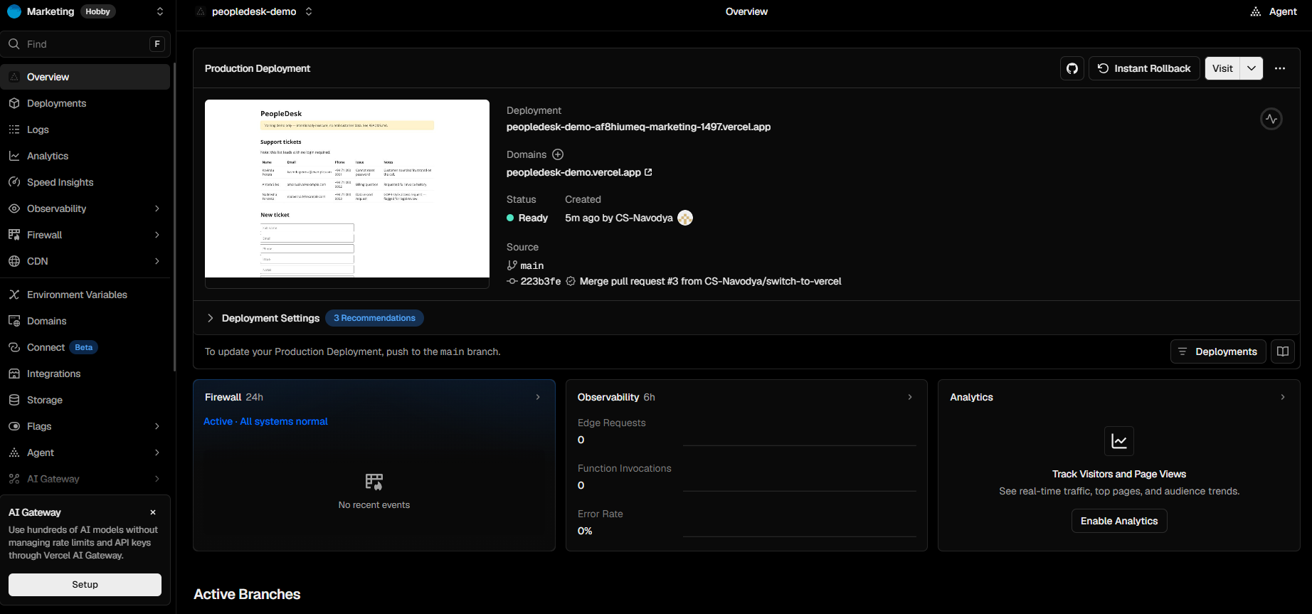
Vercel deployment page — Ready, triggered by "Merge pull request #3 from CS-Navodya/switch-to-vercel."
Live URL: https://peopledesk-demo.vercel.app/

8. Mapping findings to audit categories
How each finding above would typically surface in a real audit or compliance review:
Finding | Maps to
Merged PR with no review, no branch protection | ISO 27001 Annex A — change management / access control; SOC 2 Security criteria (change management)
Unauthenticated PII endpoint (GET /api/tickets) | GDPR Article 32 — security of processing; ISO 27001 Annex A — access control
Plaintext password logging | GDPR Article 32 — security of processing; NIS2 Article 21 — cybersecurity risk-management measures
Hardcoded secrets committed to source | ISO 27001 Annex A — secrets/credential management; SOC 2 Security criteria (logical access)
Outdated dependency with a known CVE (lodash 4.17.15) | NIS2 Article 21 — vulnerability handling; SOC 2 Security criteria (vulnerability management)

Close
Every piece of this was findable by a script or a settings page. Nothing here needed a sophisticated attacker.

